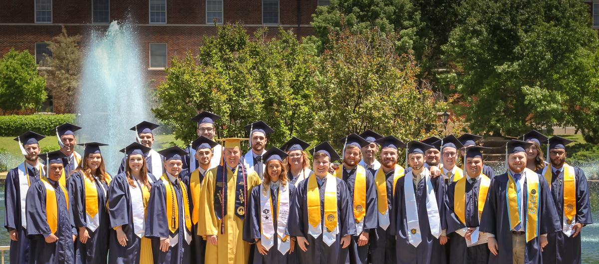
ASSP
Graduation
Stoles
The Oklahoma ASSP Chapter is selling ASSP Graduation stoles for the Fall 2021 ASSP Graduates. The stoles are white satin 72 inch stoles with the ASSP logo embroidered on the lower left side of the stole. The cost of the finished stole is $27.00.
Fall 2021 orders must be placed by November 1st, 2021 in order for the stoles to be ordered, processed, and shipped out in time for Fall Graduation. To place your order, just complete your order on the Oklahoma City ASSP Chapter website. (https://okc.assp.org/2021/01/assp-graduation-stoles/) Forms of payment include PayPal, debit, and credit cards.

If you have any questions, please feel free to contact Michael Messner at messnermik@aol.com or (405) 508-9794.

